Can Internet Regulation Prevent Fake News?

Dr Andrea De Angelis

18 marzo, 2020

## Abstract

This is an example of an RMarkdown automated report.

# Descriptives

This report uses DSP data to investigate whether Internet regulation can prevent fake news. The DSP data contains 3383 observations from year 1980 until 2019.

The v2smregcon variable measures the level of legal framework protection that the country adopted to regulate the Internet. This is the distribution of this variable:

## `stat_bin()` using `bins = 30`. Pick better value with `binwidth`.

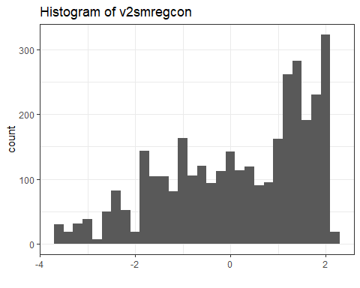

We hypothesize that better regulatory frameworks of the Internet can prevent the diffusion of fake news operated by government with the goal of propaganda. Variable v2smgovdom measures how often the government uses social media to disseminate false of misleading news to influence public opinion. We count 3383 non-missing values.  
The following histogram shows the distribution of the variable:

## `stat_bin()` using `bins = 30`. Pick better value with `binwidth`.

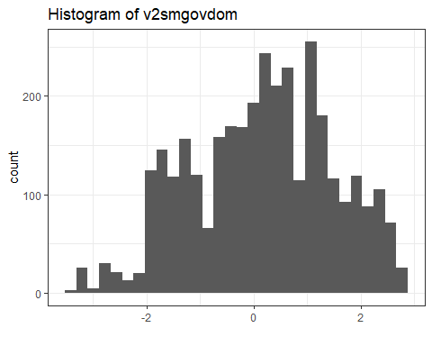

# Regression analysis

We thus estimate a linear regression model to test our hypothesis that greater regulatory framework reduces the amount of fake news. These are the results:

v2smgovdom

(1)

(2)

(3)

v2smregcon

0.615***

0.590***

0.613***

(0.011)

(0.027)

(0.025)

Constant

0.065***

-0.556***

-0.399***

(0.016)

(0.093)

(0.090)

Country FE

No

Yes

Yes

Year FE

No

No

Yes

N

3,383

3,383

3,383

R2

0.483

0.911

0.925

Adjusted R2

0.483

0.906

0.920

Residual Std. Error

0.951 (df = 3381)

0.406 (df = 3203)

0.373 (df = 3185)

F Statistic

3,162.678*** (df = 1; 3381)

182.316*** (df = 179; 3203)

199.445*** (df = 197; 3185)

*p < .1;* ***p < .05;*** p < .01